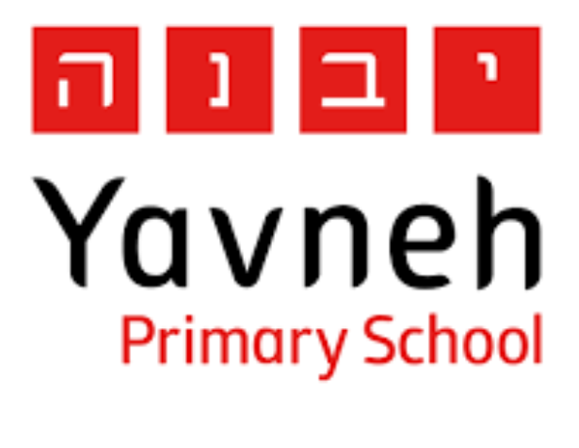

**Yavneh Primary School**

KS1 Safe Online Agreement

I will only use the Internet with an adult. I will only use my Teams account in school, with my teachers.



S

I will only click on icons and links when I know they are safe.



A

I will only send friendly and polite messages. I will not share personal information, like my name, address or telephone number.

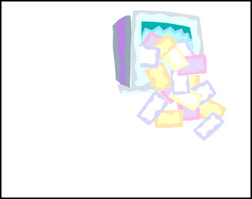

F

If I see something I do not like on a screen, I will always tell an adult.



E

My Name:

Parent Name:

Date: